**GOVERNMENT COLLEGE OF ENGINEERING ERODE**



**B.E Electronics and Communication Engineering**

**SIGN LANGUAGE TO TEXT CONVERSION FOR DEAF AND DUMB PEOPLE**

**Name of the Students: University Register no:**

GAYATHRI P 731121106013

GOHUL P 731121106014

KARTHIKA S 731121106022

THANUSH VISHAL S 731121106051

VISHAL P 731121106053

Under the mentor of

**Miss.JIMNA**

**Department of Electronics and communication engineering**

**Embedded System-Pantech eLearning**

II Floor, Kotta Srinivasiah Charities Building, Thanjavur Street, Near, Duraiswamy Subway, behind Canara Bank, T. Nagar, Chennai, Tamil Nadu 600017

## Department of Electronics and Communication Engineering

## Government College of Engineering, Erode

## Affiliated to Anna University, Chennai

## BONAFIDE CERTIFICATE

Certified that this project report **“SIGN LANGUAGE TO TEXT CONVERSION FOR DEAF AND DUMB PEOPLE”** is the bonafide work of **GAYATHRI P (731121106013), GOHUL P (731121106014), KARTHIKA S (731121106022)THANUSH VISHAL S(731121106051),VISHAL P (731121106053)** students of B.E in the Dept. of Electronics and Communication Engineering, GCE, Near vasavi College, Erode, Tamil Nadu-638316, affiliated to ANNA UNIVERSATY (CHENNAI), During the academic year 2021-2025.

**Signature of Class Advisor Signature of HOD**

Mrs.S.K.Fairoze Banu  M.E Mr.M.Raja M.E

Assistant Professor,ECE HoD ECE

GCE Erode GCE Erode

**TABLE OF CONTENT**

|  |  |  |
| --- | --- | --- |
| SI.NO | Description | Page.No |
| 01 | BONAFIDE CERTIFICATE | 02 |
| 02 | ACKNOWLEDGEMENT | 04 |
| 03 | ABSTRACT | 05 |
| 04 | OBJECTIVE | 06 |
| 05 | INTRODUCTION | 07 |
| 06 | WORKING PRINCIPLE | 08 |
| 07 | BLOCK DIAGRAM | 08 |
| 08 | CIRCUIT DIAGRAM | 09 |
| 09 | HARDWARE DESCRIPTION | 10 |
| 10 | ARDUINO CODE | 14 |
| 11 | ADVANTAGES | 19 |
| 12 | CONCLUSION AND FUTURE SCOPE | 20 |

**ACKNOWLEDGEMENT**

Support on demand, encouragement at the needed moment and guidance in the right direction are indispensable for the success of any project. We have received these in excess from all corners from various people and we are glad to submit our gratitude to them.

We would like to express our heartfelt thanks to the Management of GOVERNMENT COLLEGE OF ENGINEERING, ERODE, for giving us the opportunity to undergo our internship program.

We thank Dr. A. SARADHA, M.E., Ph.D., the esteemed Head of our Institution who has been a source of motivation to all the staffs and students of our college. We are so much thankful.

Our sincere thanks to Mr.M. RAJA, M.E., Head of the Department for his continuous support and motivation to undergo this internship.

We extend our profound gratitude to our class advisor Mrs.S.K.Fairoze Banu, M.E Assistant Professor, Department of Electronics and Communciation Engineering and all teaching and nonteaching staff members, for their valuable guidance and support.

We are thankful to Pantech e-Learning for offering us comprehensive and in-depth internship training on Embedded using Rasperry pi and Arduino

**ABSTRACT**

Sign Language Recognition is one of the most growing fields of research area. Many new techniques have been developed recently in this area. The Sign Language is mainly used for communication of deaf-dumb people. It is most commonly used by deaf and dumb people who have hearing or speech problems to communicate among themselves or with normal people.

The integration of sign language to text conversion technology represents a significant advancement in enhancing communication for deaf and dumb individuals. By using flex sensor it detects hand movements and provides an accessible communication bridge between those who rely on sign language and the wider population, who may not be familiar with it.

The development of this technology aims to address communication barriers, promote inclusivity, and empower deaf and dumb individuals by enabling more straightforward and independent interactions in various social, educational, and professional settings. The potential applications are vast, including improved access to services, better educational outcomes, and more meaningful participation in community life. As this technology continues to evolve, it holds the promise of fostering greater understanding and acceptance of sign language, contributing to a more inclusive society.

**OBJECTIVE**

The primary objective of sign language to text conversion for deaf and dumb people is to enhance communication by translating sign language into written text in real-time. This technology aims to:

1. Bridge Communication Gaps: Facilitate seamless interaction between deaf and dumb individuals and those who do not understand sign language, reducing communication barriers.

2. Promote Inclusivity: Enable deaf and dumb people to participate more fully in various social, educational, and professional environments by providing a more accessible means of communication.

3. Empower Independence: Allow deaf and dumb individuals to communicate independently without relying on interpreters, thereby increasing their autonomy.

4. Enhance Accessibility: Improve access to services, information, and opportunities by making communication more straightforward and efficient for those who use sign language.

5. Foster Understanding: Raise awareness and understanding of sign language within the broader community by integrating this technology into everyday interactions.

**CHAPTER 1**

**INTRODUCTION**

Sign Language is the most natural and expressive way for the hearing impaired people. People, who are not deaf, never try to learn the sign language for interacting with the deaf people. This leads to isolation of the deaf people

It is a vital mode of communication for deaf and dumb individuals, allowing them to express themselves and interact with others. However, the lack of widespread understanding of sign language among the general population can create barriers, making communication challenging. To bridge this gap, sign language to text conversion technology has emerged as a powerful tool.

The development and implementation of sign language to text conversion systems have the potential to transform various aspects of daily life, from education and employment to social interactions and access to services. It empowers deaf and dumb individuals by providing them with a voice that can be easily understood by those unfamiliar with sign language, fostering greater inclusion and understanding in society.

**CHAPTER 2**

**Working Principle**

1.The value taken from flex sensor based on its bending. Flex sensor gives certain angle value for each bend.

2: The value is obtained on the microcontroller for further process.

3: Microcontroller process its value and display the output based on the coding.

4: The output can be viewed on I2c lcd display.

**CHAPTER 3**

**BLOCK DAIGRAM**

Hand sign detected by Flex Sensor

Hand sign deSsstected by Flex Sensor

Hand sign detected by Flex Sensor

Sensed Data is sent to microcontroller

Microcontroller Process data based on Given Condition

Microcontroller Processed data based on Given Condition

fccx

The Output can be displayed on I2C Lcd Display

**CHAPTER 4**

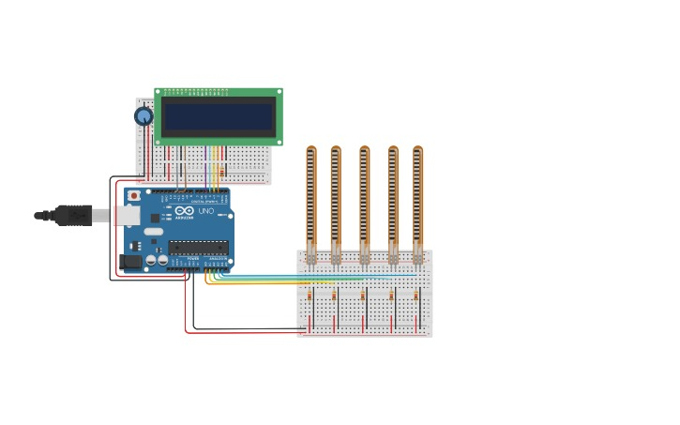**CIRCUIT**

**COMPONENTS REQUIRED**

1)Arduino uno

2)LCD Display

3)Flex sensor

**SOFTWARE REQUUIRED**

Arduino IDE

**CHAPTER 5**

## HARDWARE DESCRIPTION

### **ARDUINO UNO**

Arduino UNO is a low-cost, flexible, and easy-to-use programmable opensource microcontroller board that can be integrated into a variety of electronic projects. This board can be interfaced with other Arduino boards, Arduino shields, Raspberry Pi boards and can control relays, LEDs, servos, and motors as an output. Arduino UNO features AVR microcontroller Atmega328, 6 analogue input pins, and 14 digital I/O pins out of which 6 are used as PWM output.

This board contains a USB interface i.e. USB cable is used to connect the board with the computer and Arduino IDE (Integrated Development Environment) software is used to program the board. The unit comes with 32KB flash memory that is used to store the number of instructions while the SRAM is 2KB and EEPROM is 1KB.

The operating voltage of the unit is 5V which projects the microcontroller on the board and its associated circuitry operates at 5V while the input voltage ranges between 6V to 20V and the recommended input voltage ranges from 7V to 12V.

### Arduino UNO Components

The Arduino UNO board contains the following components and specifications:

1. ATmega328: This is the brain of the board in which the program is stored.
2. Ground Pin: there are several ground pins incorporated on the board.
3. PWM: the board contains 6 PWM pins. PWM stands for Pulse Width Modulation, using this process we can control the speed of the servo motor, DC motor, and brightness of the LED.
4. Digital I/O Pins: there are 14 digital (0-13) I/O pins available on the board that can be connected with external electronic components.
5. Analogue Pins: there are 6 analogue pins integrated on the board. These pins can read the analogue sensor and can convert it into a digital signal.
6. AREF: It is an Analog Reference Pin used to set an external reference voltage.
7. Reset Button: This button will reset the code loaded into the board. This button is useful when the board hangs up, pressing this button will take the entire board into an initial state.
8. USB Interface: This interface is used to connect the board with the computer and to upload the Arduino sketches (Arduino Program is called a Sketch)
9. DC Power Jack: This is used to power up the board with a power supply.

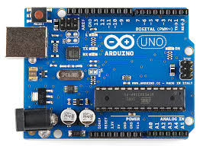

ARDUINO UNO

**FLEX SENSOR**

A flex sensor is a [kind of sensor](https://www.elprocus.com/laser-sensor-working-and-its-applications/) which is used to measure the amount of defection otherwise bending. The designing of this sensor can be done by using materials like plastic and carbon. The carbon surface is arranged on a plastic strip as this strip is turned aside then the sensor’s resistance will be changed. Thus, it is also named a bend sensor. As its varying resistance can be directly proportional to the quantity of turn thus it can also be employed like a goniometer.

**Pin Configuration**

The pin configuration of the flex sensor is shown below. It is a two-terminal device, and the terminals are like p1 & p2. This sensor doesn’t contain any polarized terminal such as diode otherwise [capacitor](https://www.elprocus.com/ceramic-capacitor-working-construction-applications/), which means there is no positive & negative terminal. The required voltage of this sensor to activate the sensor ranges from 3.3V -5V DC which can be gained from any type of interfacing.

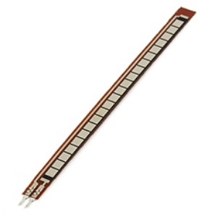

FLEX-SENSOR-PIN-CONFIGURATION

* Pin P1: This pin is generally connected to the +ve terminal of the power source.
* Pin P2: This pin is generally connected to GND pin of the power source.

## LCD DISPLAY

The term LCD stands for liquid crystal display. It is one kind of electronic display module used in an extensive range of applications like various circuits & devices like mobile phones, calculators, computers, TV sets, etc. These displays are mainly preferred for multi-segment light-emitting diodes and seven segments. The main benefits of using this module are inexpensive; simply programmable, animations, and there are no limitations for displaying custom characters, special and even animations, etc.

LCDs are available to display arbitrary images (as in a general-purpose computer display) or fixed images with low information content, which can be displayed or hidden: preset words, digits, and [seven-segment displays](https://en.wikipedia.org/wiki/Seven-segment_display) (as in a digital clock) are all examples of devices with these displays. They use the same basic technology, except that arbitrary images are made from a matrix of small [pixels](https://en.wikipedia.org/wiki/Pixel), while other displays have larger elements.

LCDs can either be normally on (positive) or off (negative), depending on the polarizer arrangement. For example, a character positive LCD with a backlight will have black lettering on a background that is the color of the backlight, and a character negative LCD will have a black background with the letters being of the same color as the backlight.

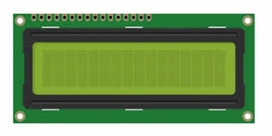

**LCD DISPLAY 16×2**

**CHAPTER 5**

**ARDUINO CODE**

#include "SoftwareSerial.h"

#include <LiquidCrystal_I2C.h>

#include <SoftwareSerial.h>

SoftwareSerial mySerial(3, 2);

LiquidCrystal_I2C lcd (0x27, 16, 2);

#define blue 2

#define green 3

#define red 4

unsigned int f;

unsigned int g;

unsigned int h;

void setup () {

pinMode(blue, OUTPUT);

pinMode(green, OUTPUT);

pinMode(red, OUTPUT);

Serial.begin(9600);

mySerial.begin(9600);

Serial.println();

lcd.begin();

lcd.backlight();

lcd.setCursor(0, 0);

lcd.print(" Welcome To");

lcd.setCursor(0, 1);

lcd.print("JustDoElectronic");

lcd.clear();

delay (3000);

}

void loop ()

{

f = analogRead(1);

g = analogRead(2);

h = analogRead(3);

Serial.print("Flex Sensor:");

Serial.println(f);

delay (1000);

if (f >312) {

digitalWrite(blue, HIGH);

digitalWrite(green, LOW);

digitalWrite(red, LOW);

mySerial.println("Plz Give Me Water");

lcd.clear();

lcd.setCursor(0, 0);

lcd.print(" Plz Give Me");

lcd.setCursor(0, 1);

lcd.print(" Water ");

delay (3000);

lcd.clear();

lcd.setCursor(0, 0);

lcd.print(" If Anything");

lcd.setCursor(0, 1);

lcd.print(" You Want ");

}

else if (f <250) {

digitalWrite(blue, HIGH);

digitalWrite(green, LOW);

digitalWrite(red, LOW);

mySerial.println("Plz Give Me Water");

lcd.clear();

lcd.setCursor(0, 0);

lcd.print(" Plz Give Me");

lcd.setCursor(0, 1);

lcd.print(" food ");

delay (3000);

lcd.clear();

lcd.setCursor(0, 0);

lcd.print(" If Anything");

lcd.setCursor(0, 1);

lcd.print(" You Want ");

}

else {

}

delay (200);

}

**OUTPUT**

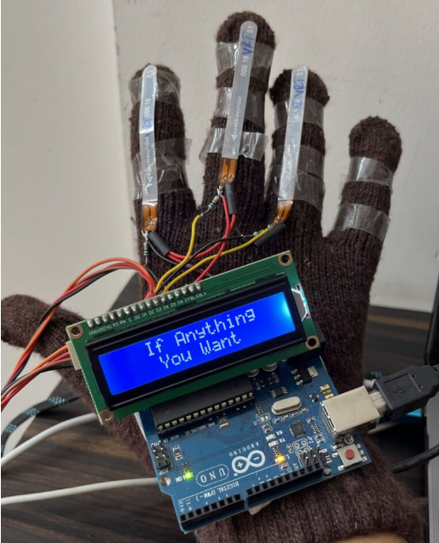

**CHAPTER 7**

**ADVANTAGES**

Sign language to text conversion technology offers several advantages for deaf and dumb individuals, significantly improving their quality of life and enhancing their ability to interact with the broader community. Here are some key benefits:

1.Improved Communication: Converts sign language into text in real-time, allowing deaf and dumb individuals to communicate more easily with those who do not understand sign language.

2. Increased Independence: Reduces the need for interpreters, empowering individuals to communicate independently in various settings, such as at work, in educational institutions, or during everyday interactions.

3. Enhanced Accessibility: Provides access to services, information, and opportunities that might otherwise be challenging for deaf and dumb individuals, such as customer service, online communication, and public announcements.

4. Greater Inclusivity: Facilitates the inclusion of deaf and dumb individuals in social, educational, and professional environments by making it easier for them to participate in conversations and activities.

5. Time and Cost Efficiency: Reduces the need for manual interpretation services, which can be costly and time-consuming, especially in situations where interpreters are not readily available.

6. Personalized Communication: Allows for more personalized and private communication, as individuals can use the technology directly without needing to rely on a third party.

7. Increased Awareness: Encourages greater understanding and acceptance of sign language within the broader community, as more people become aware of and interact with this technology.

**CHAPTER 8**

**CONCLUSION AND FUTURE SCOPE**

In this project, we designed the Sign Language to Text Conversion With Arduino Module. and is working fine but there is no voice I mean it always sees the Mobile App. that’s why we decided in future we begin again the same project with Voice Module.

In future work, proposed system can be developed and implemented using Raspberry Pi. Image Processing part should be included so that System would be able to communicate in both directions i.e.it should be capable of converting normal language to sign language and vice versa. We will try to recognize signs which include motion. Moreover we will focus on converting the sequence of gestures into text i.e. word and sentences and then converting it into the speech which can be heard.